ANUHA BUZZ

Issue #14
December 2023

FROM THE CEO

Hi All,

Anuha delivered over 60,000 hours of care to our NDIS participants across the Lockyer Valley during 2023, that really is remarkable. It delivered a supported employment program for our participants through the MRF and of course our fabulous Kitchen Crew. It also successfully delivered our transfer station contracts across the 8 sites in the valley. A busy year.

So I would like to take this opportunity to thank you all for your hard work and dedication. Please take the opportunity over the festive season to take a break and refresh. I have no doubts that 2024 will also be a busy year.

Have a great Christmas and new year everybody.

Colin Tidswell

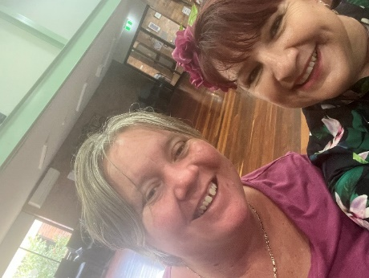
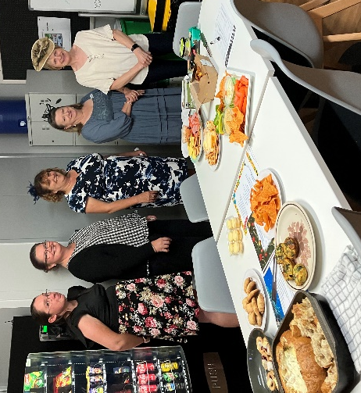
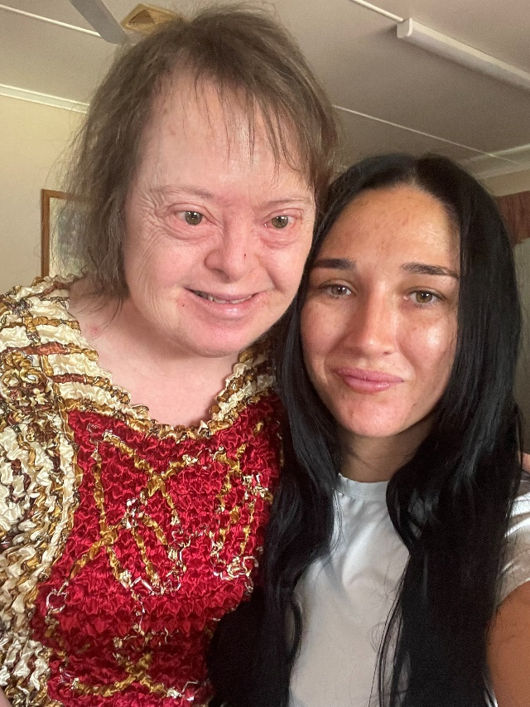
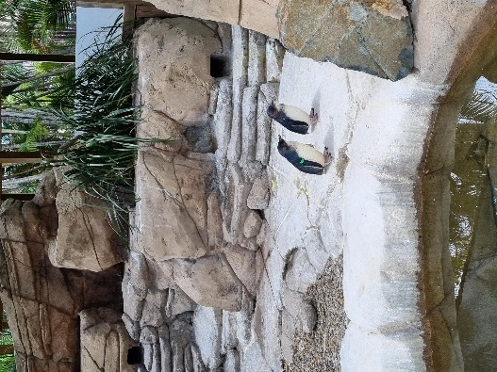
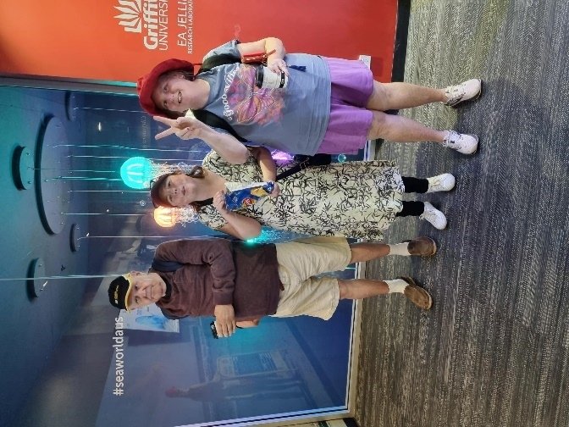
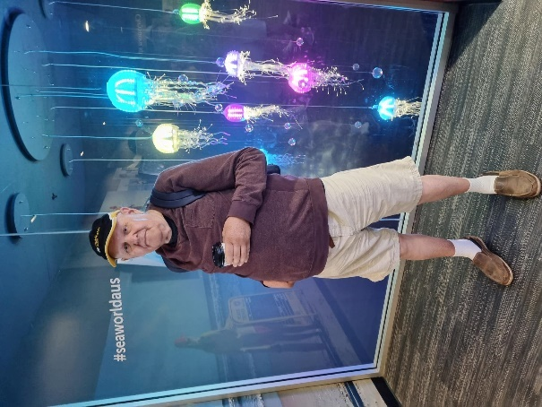
Melbourne Cup at the office.
Tracey Devereux and Shandell Reisenleiter at the Gatton Senior Citizen Centre for Church Craft and Melbourne Cup Day luncheon.
A day of support

Mandy wanted to share this lovely photo with her support worker Cody.

A day out at
Sea World.

We were able to explore the park and see a variety of animals.
WHAT HAVE YOU MISSED…
DISABILITY ACTION WEEK 2023
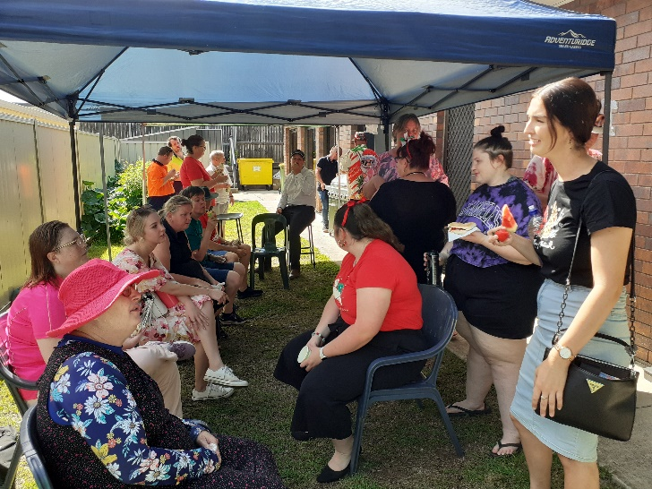
We celebrated Disability Action Week by inviting all our participants to a ‘Brekky BBQ’ followed by a ‘day at the pool’ to cool down. It was a fantastic day!

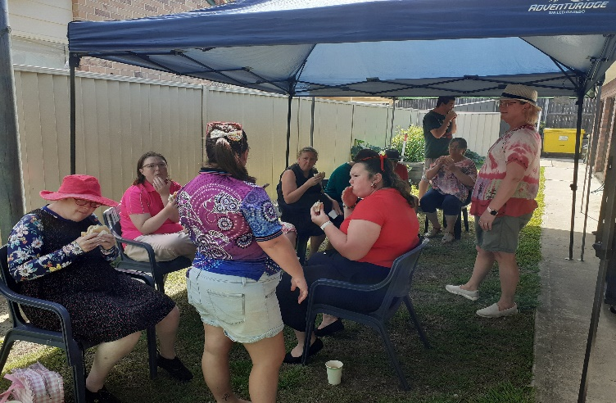
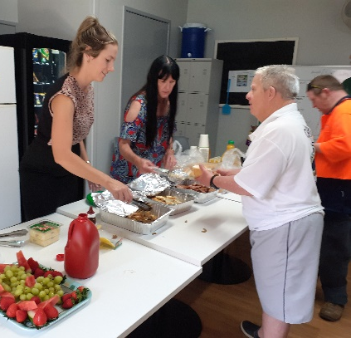
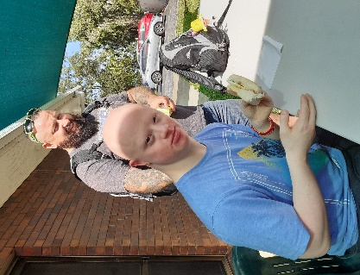
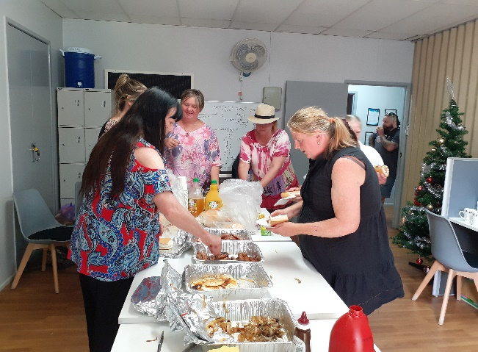
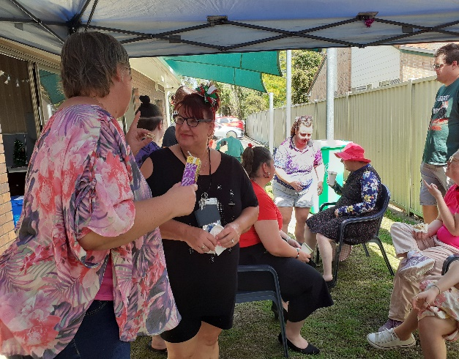
CRAFT DAYS

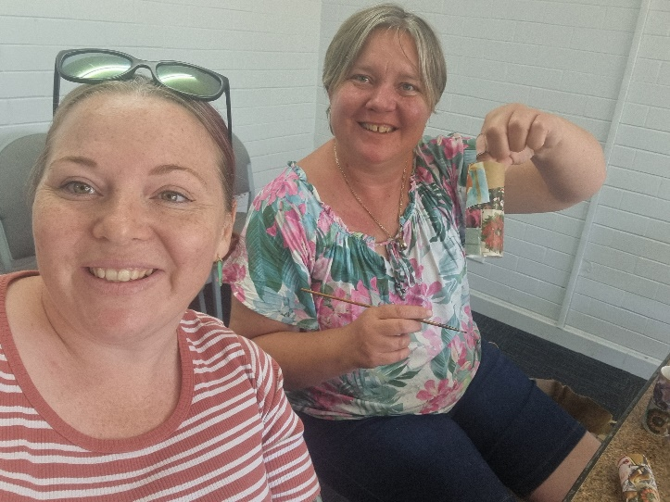
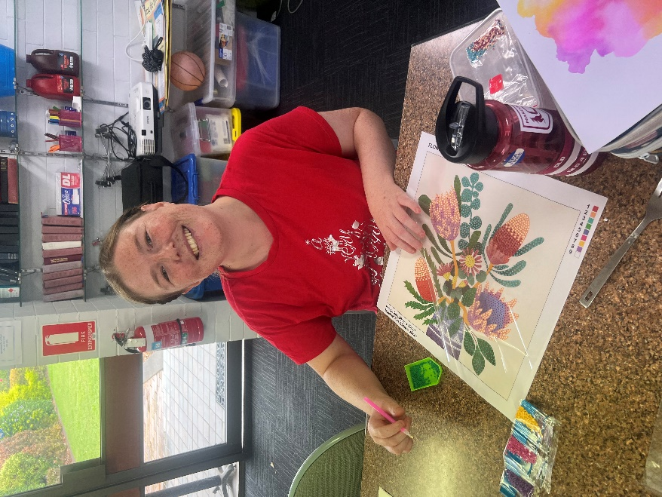
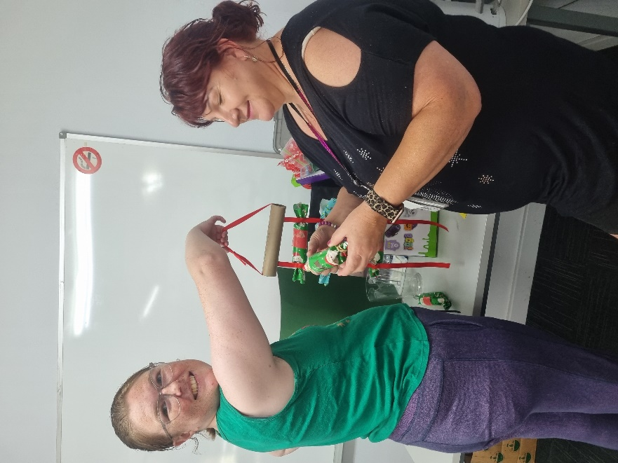
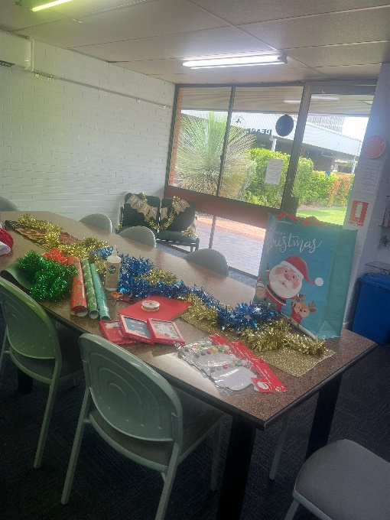
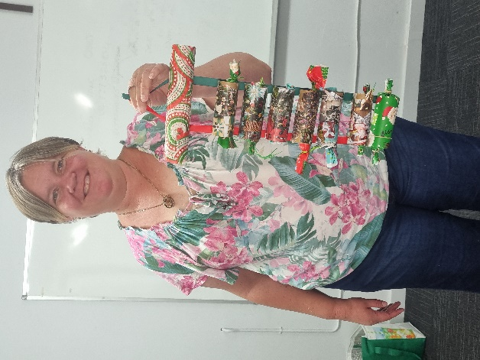
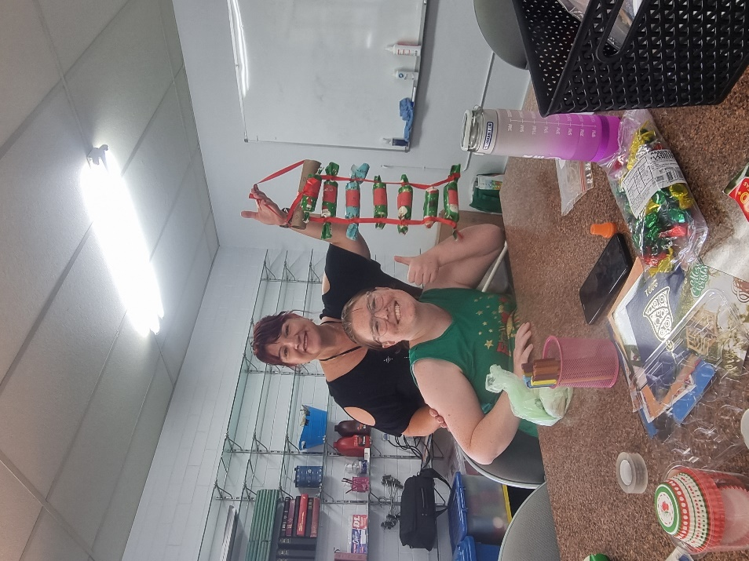
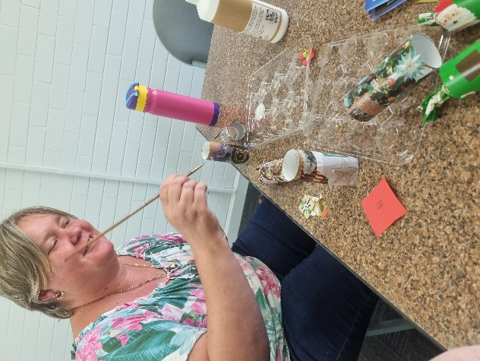
GROUNDWATER – COUNTRY MUSIC FESTIVAL

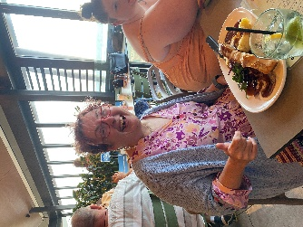
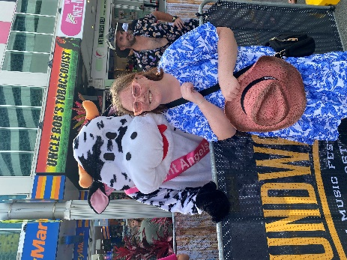
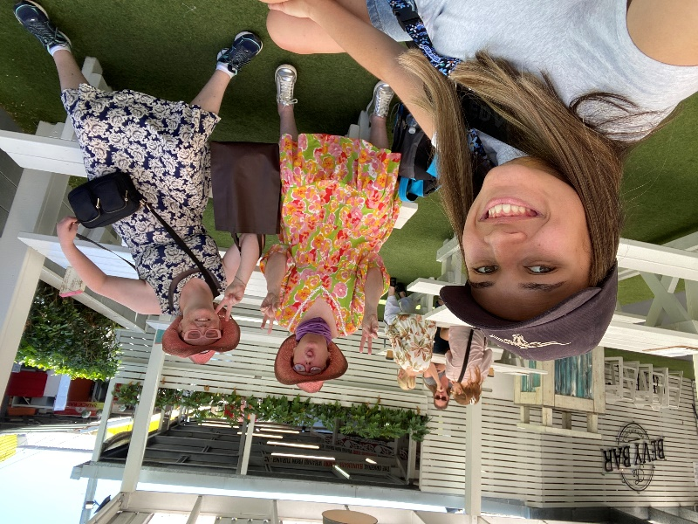
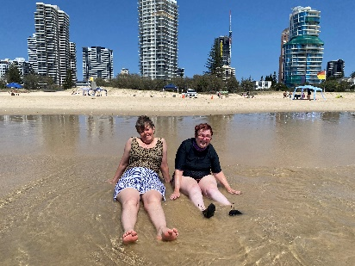
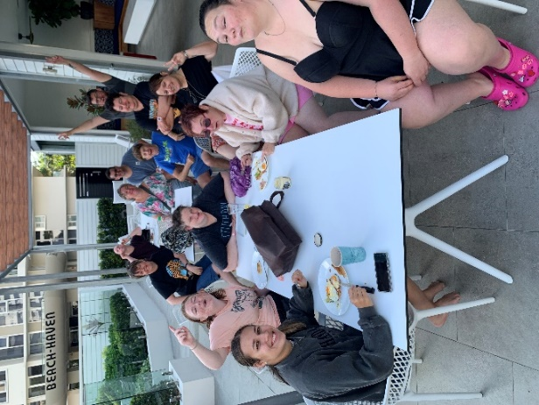
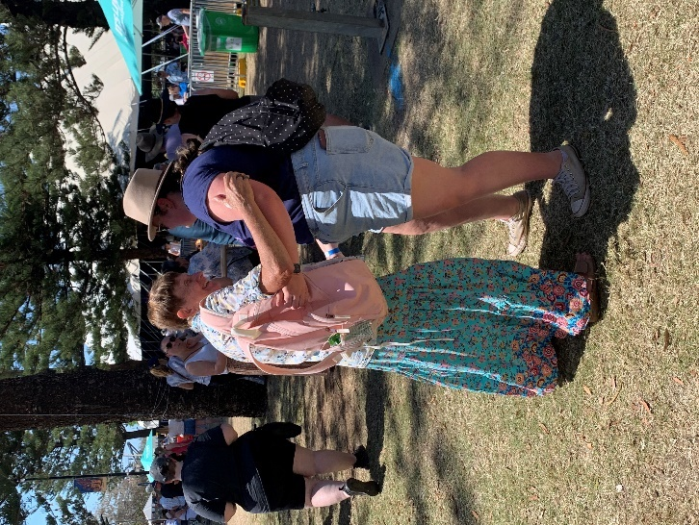
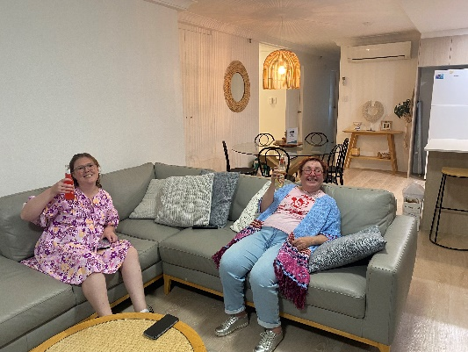
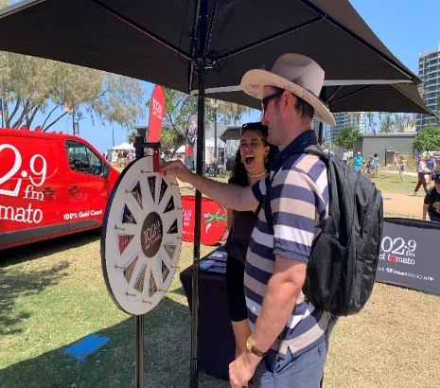
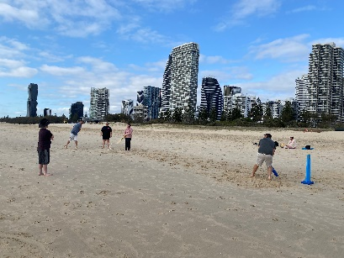
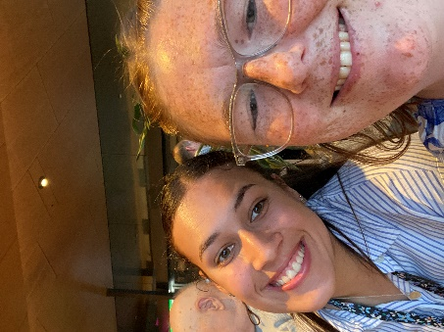
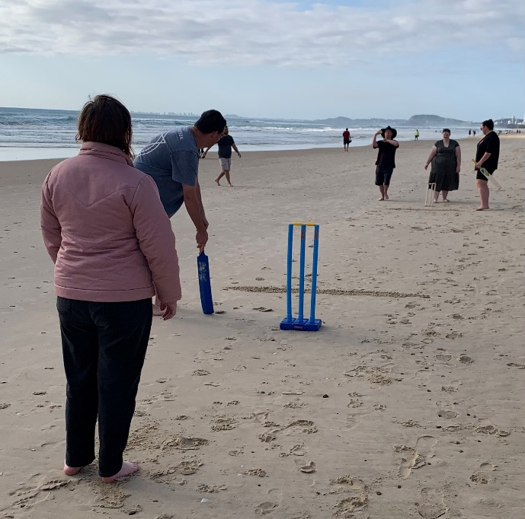
GROUNDWATER - CONTINUED
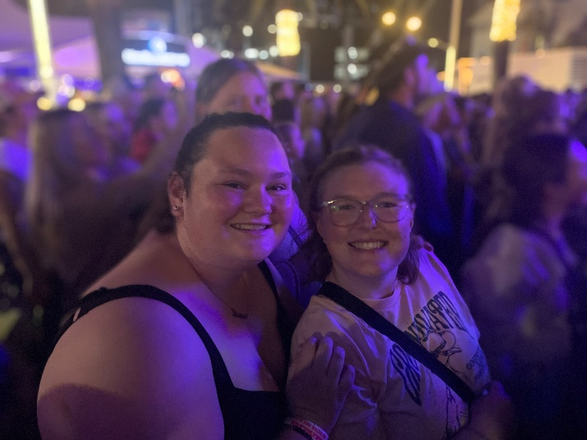
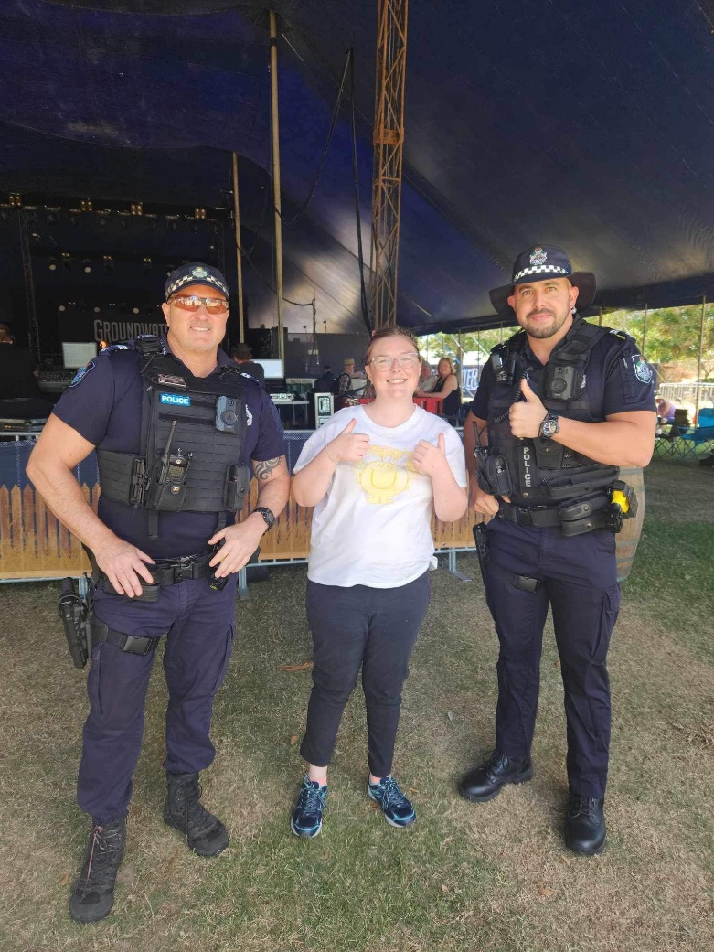
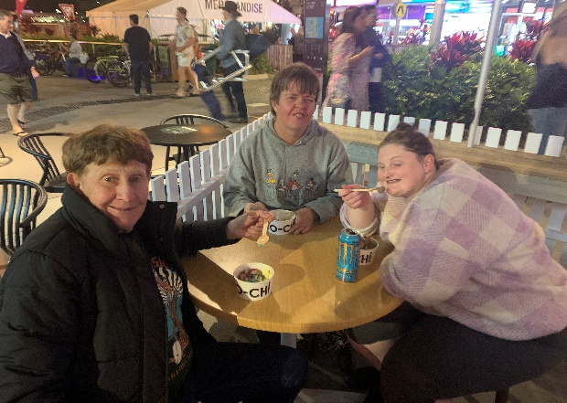
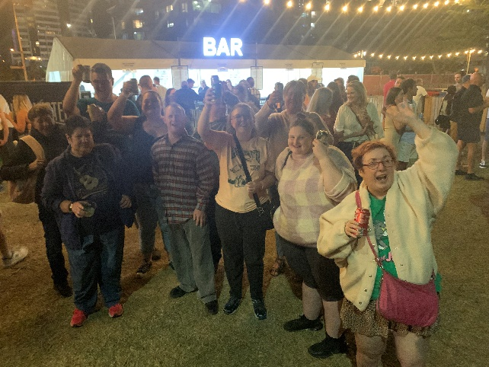
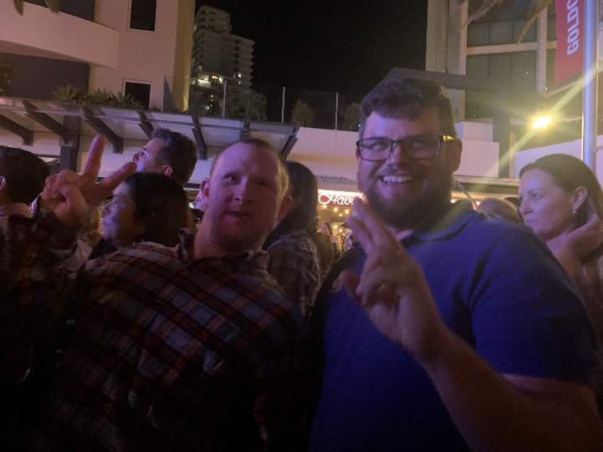
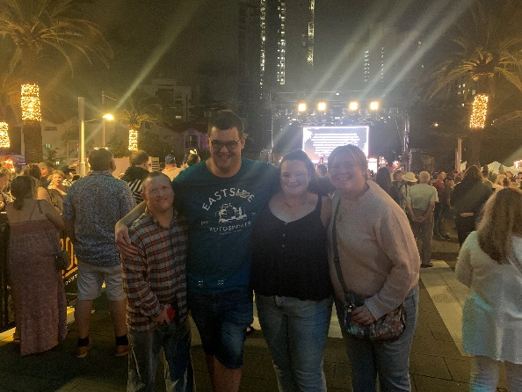
GROUNDWATER - CONTINUED
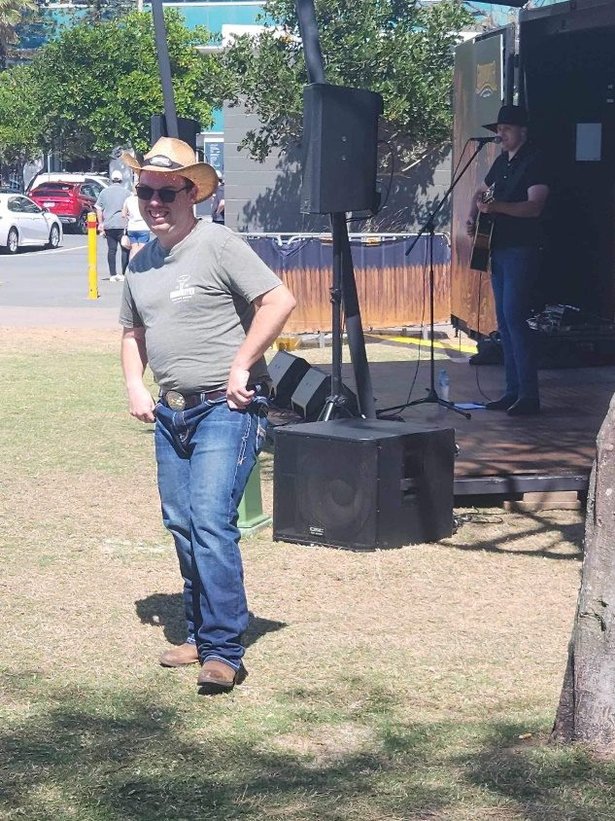
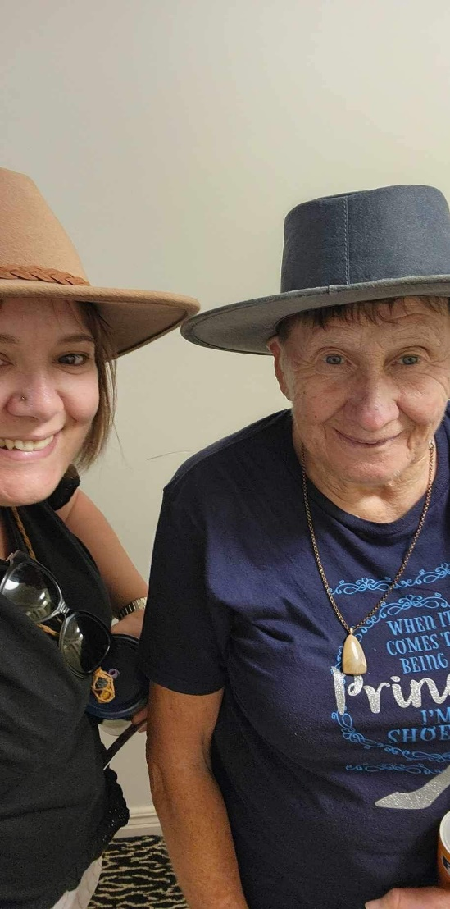
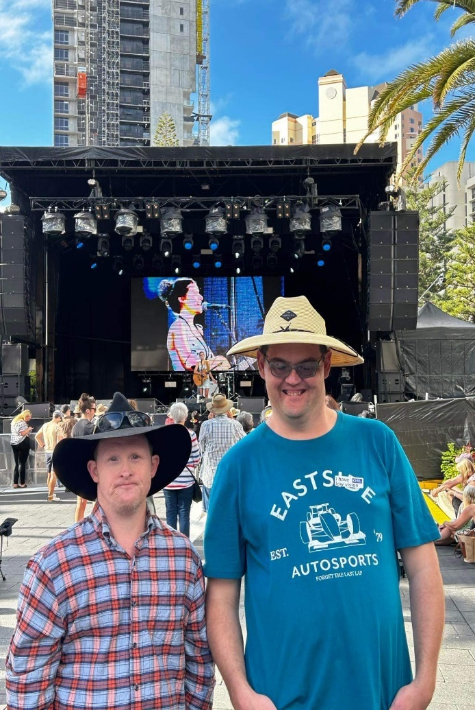
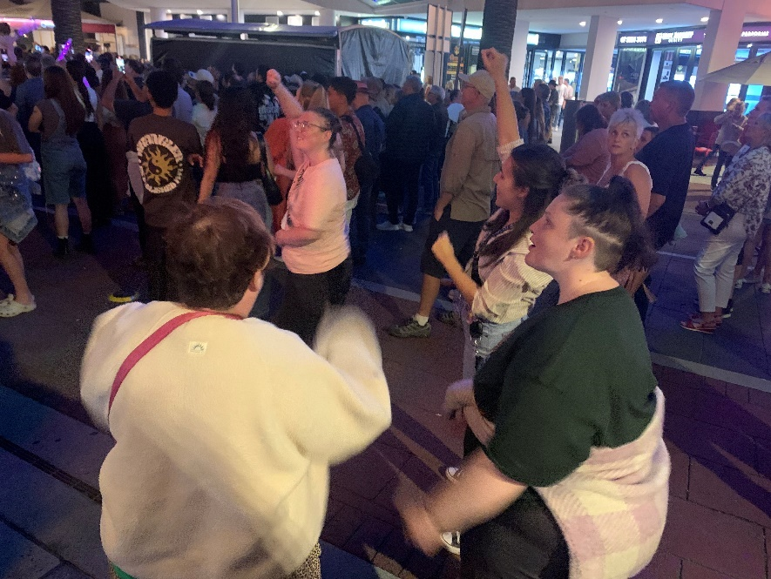
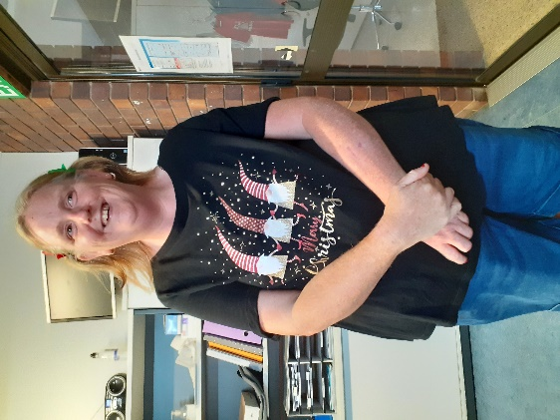
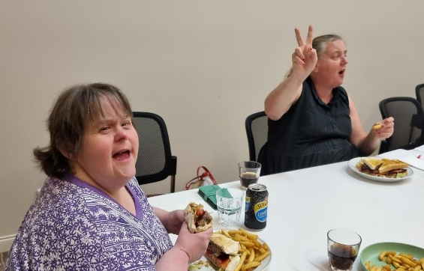
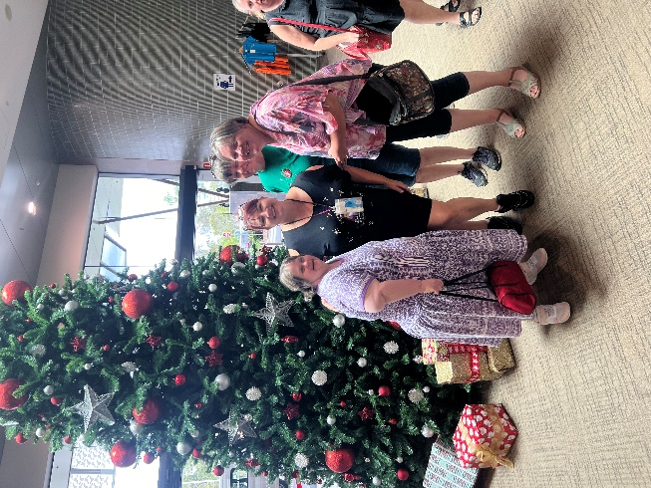
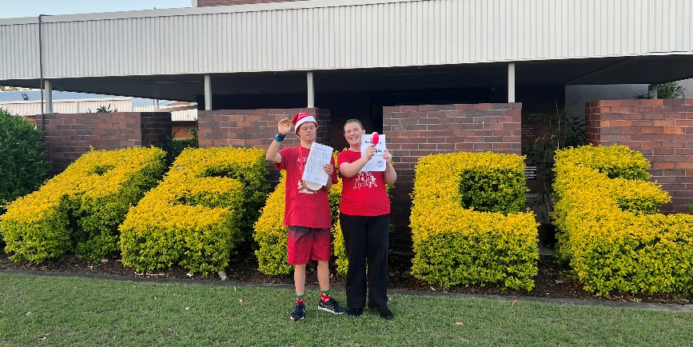
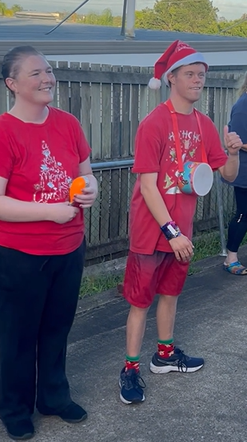
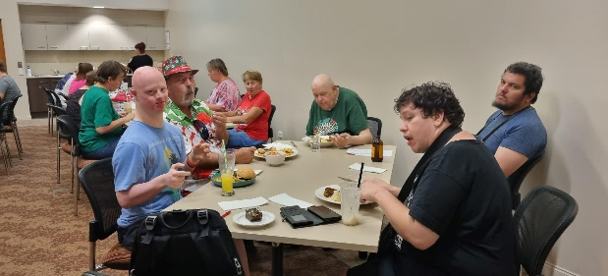
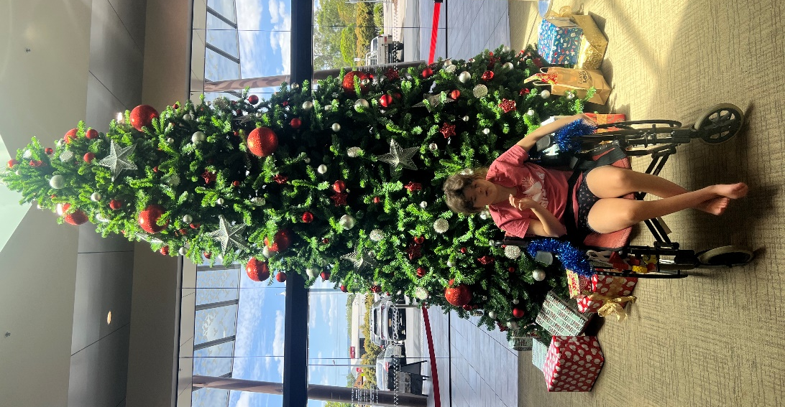
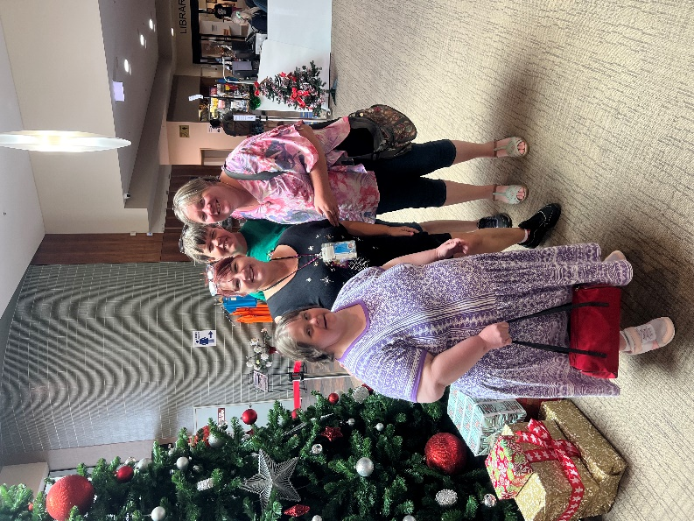
CHRISTMAS CELEBRATIONS
Christmas Carolling was a hit!
Shandell put some tinsel around Kiarni's wheelchair and took her out to the Cultural centre for the day.
She played soft music on her phone while they explored the library. Such joy!
STAFF CHRISTMAS PARTY / YEARS OF SERVICE
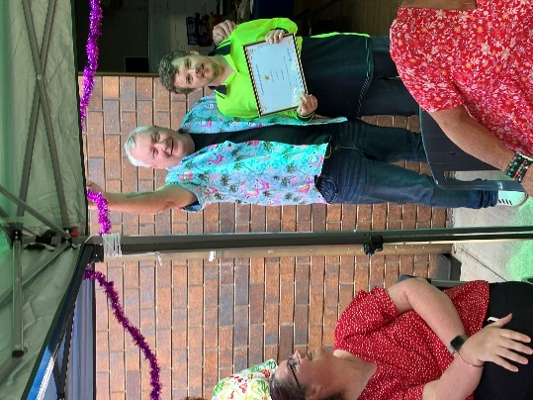
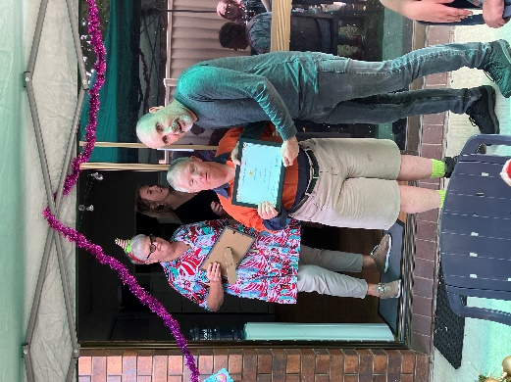
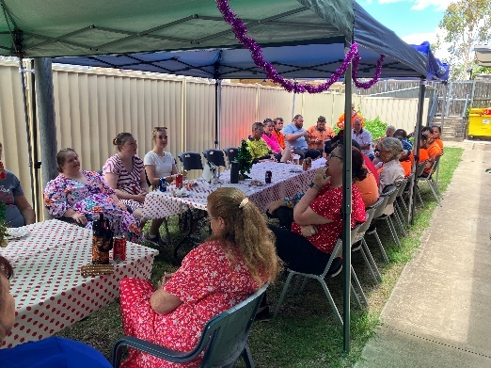
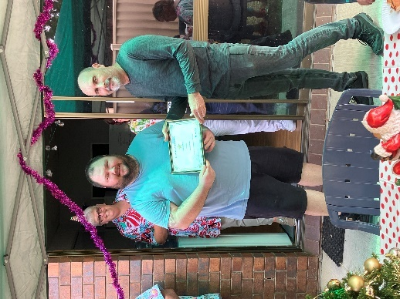
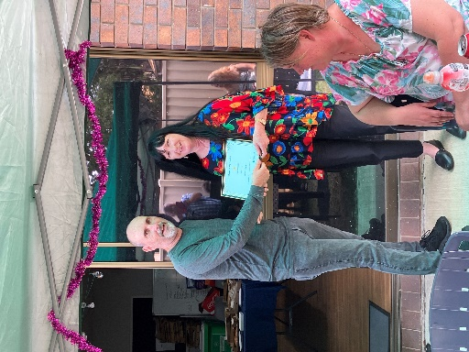
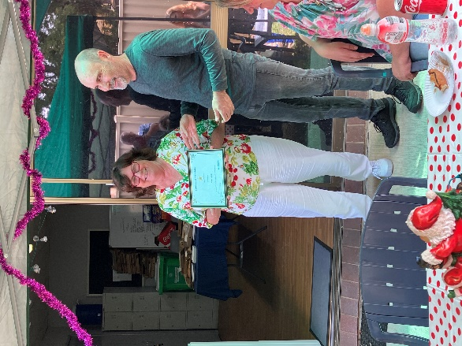
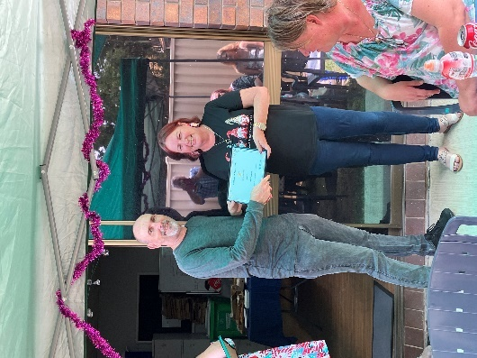
At our staff Christmas Party, we celebrated our staff who have reached a milestone of over 5 years of service with Anuha. There are quite a few to mention:
Hayden Dittmann | 5 Years
Mark Gordon | 5 Years
Anne Kelly | 5 Years
Tracey Porter | 5 Years
Chantelle Ramage | 5 Years
Ken Ravot | 5 Years
Katrina Wills | 5 Years
Casey Carr | 6 Years
Gary Dallinger | 6 Years
Sue Graveur | 6 Years
Shona Julian | 6 Years
Kathy Mardesic | 6 Years
Ken Stenhouse | 6 Years
Tanya Dittmann | 7 Years
John Hoffmann | 7 Years
Helen Johns | 7 Years
Ernest Koffal | 8 Years
Lee-Anne Stopps | 8 Years
Jodie Van Ansem | 8 Years
Jennifer Crisci | 10 Years
Thomas King | 10 Years
Corey Hilan | 11 Years
Ian Muckert | 13 Years
Scott Retschlag | 13 Years
Darelle Manttan | 14 Years
Tracey Worldon | 15 Years
Gregory Cumming | 16 Years
Cindy Garbutt | 16 Years
Jamie Haupt | 16 Years
Benjamin Grant | 17 Years
Ken Philp | 17 Years
Trudi Laidlaw | 18 Years
Keven Montgomery | 18 Years
Craig Coulter | 19 Years
Craig Zampech | 19 Years
John Hunter | 28 Years
Sue Taylor | 29 Years

PARTICIPANT CHRISTMAS PARTY

What a great night!
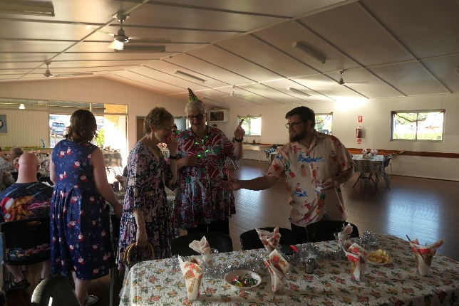
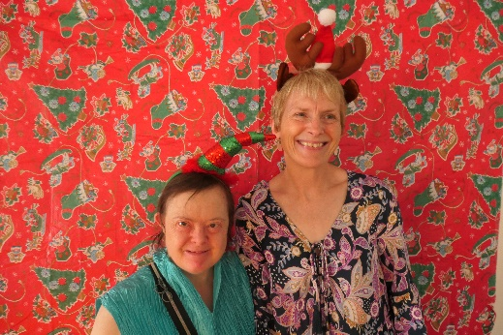
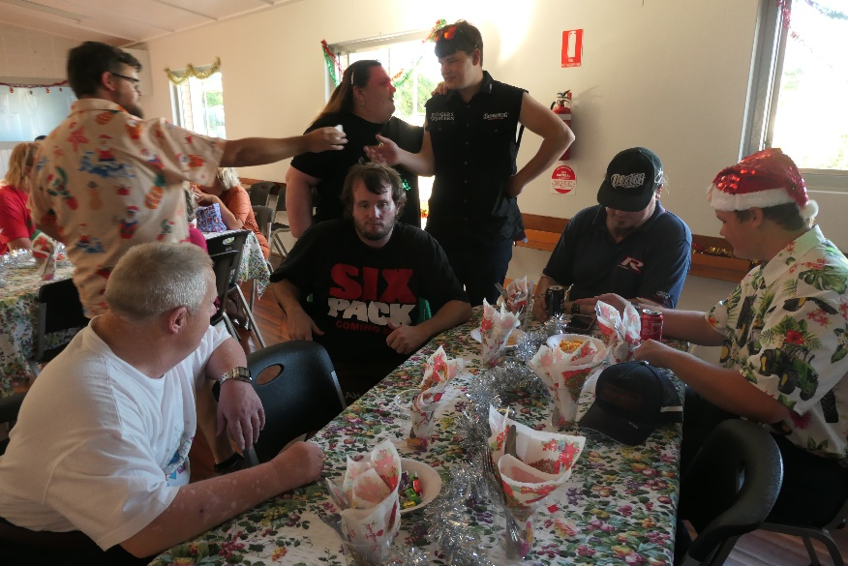
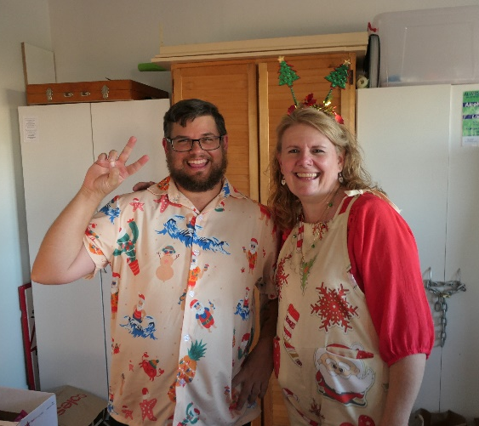
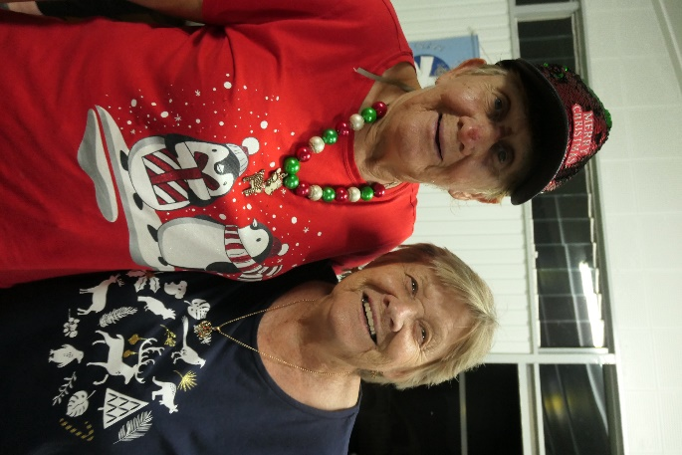
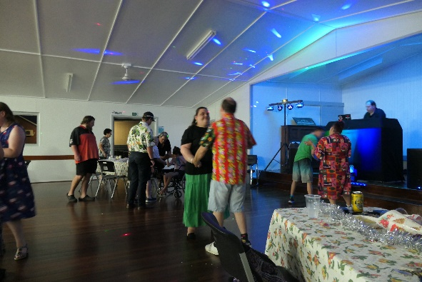
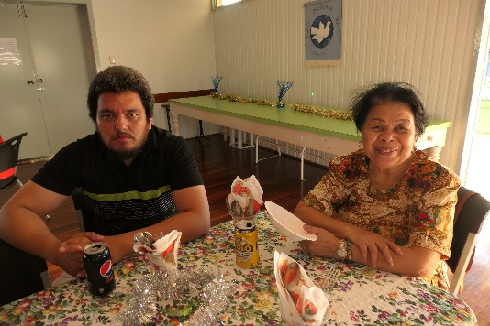
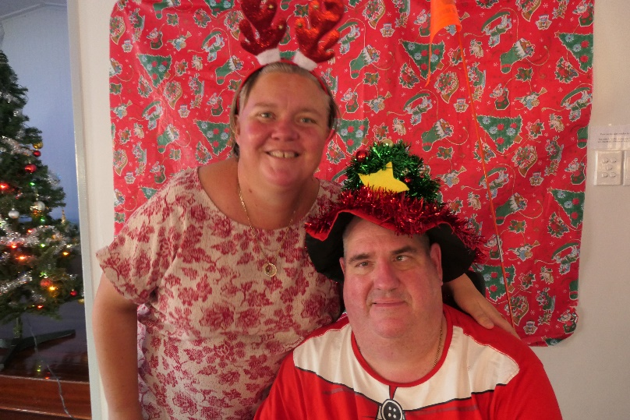
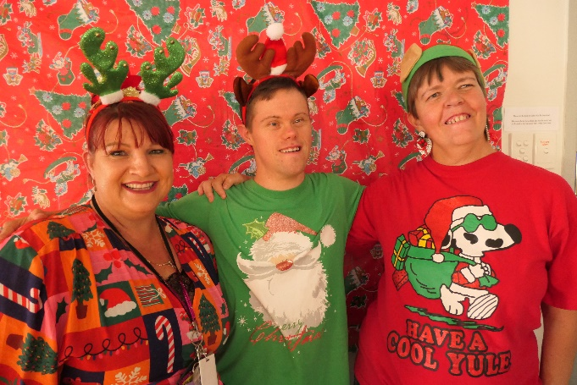
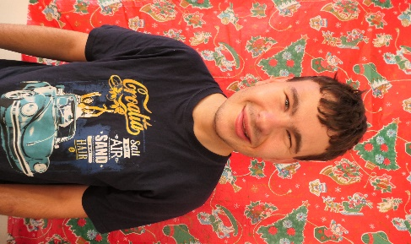
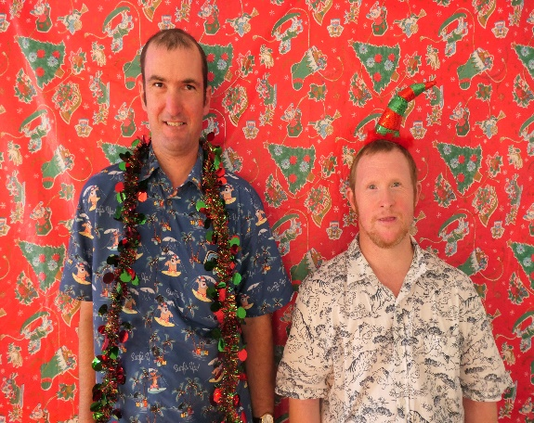
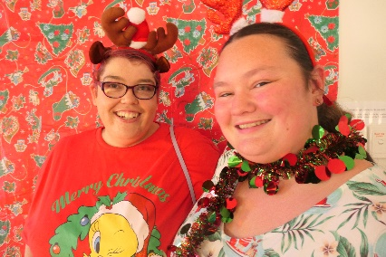
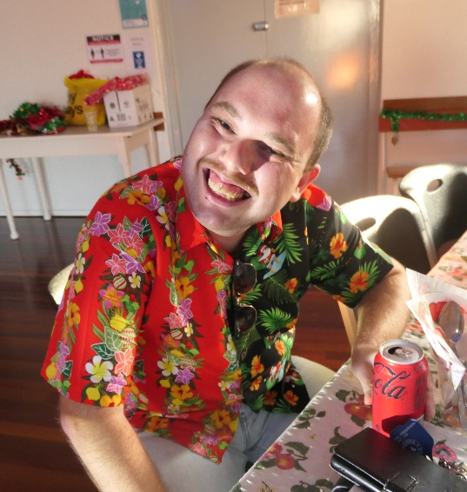
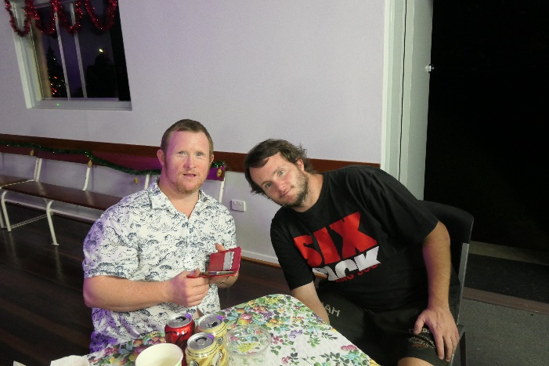
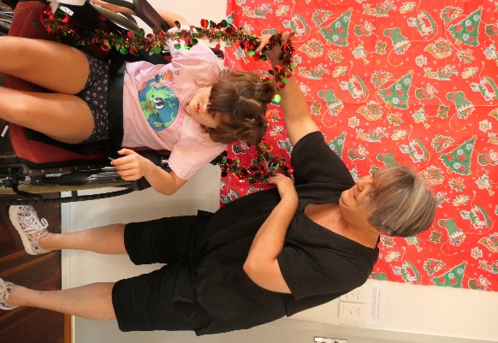
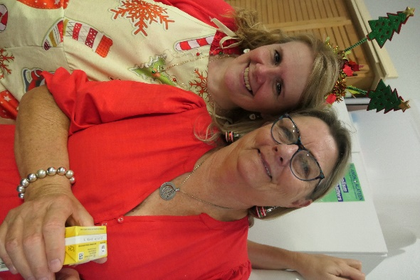
PEACE HAVEN RESIDENTS CHRISTMAS PARTY
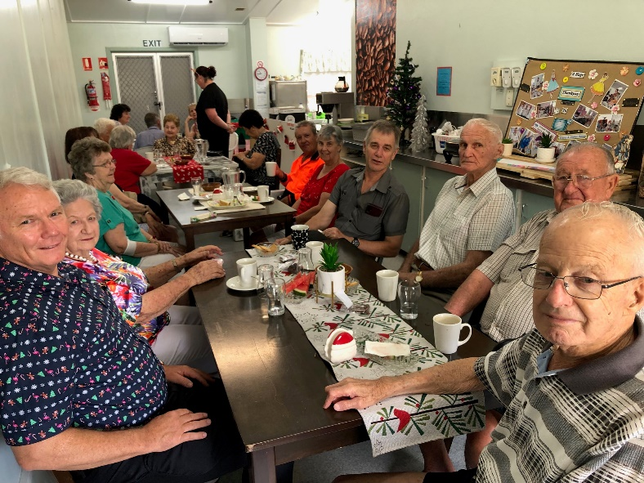
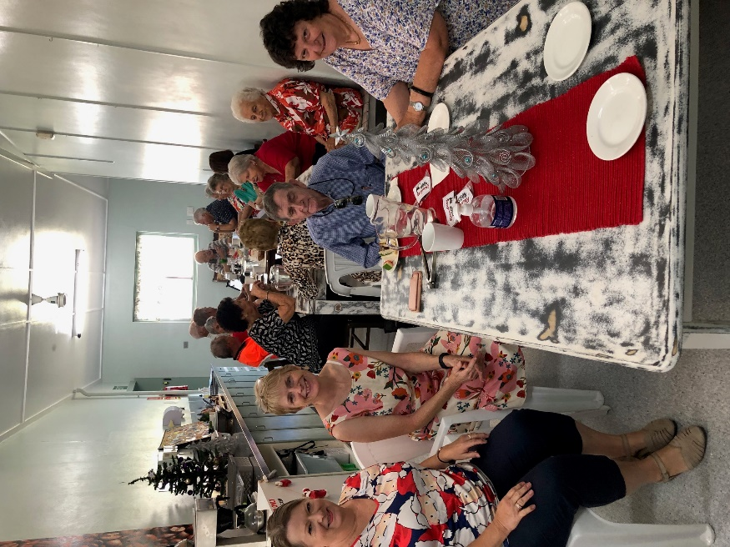
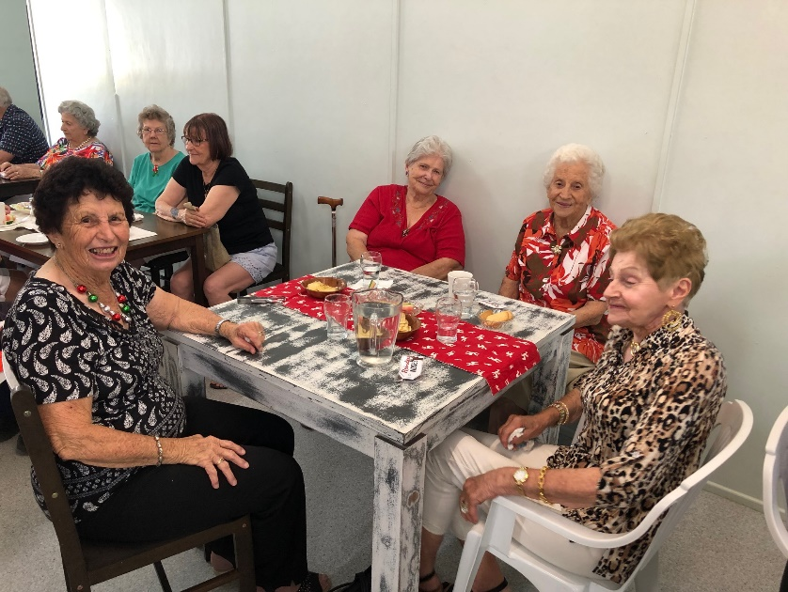
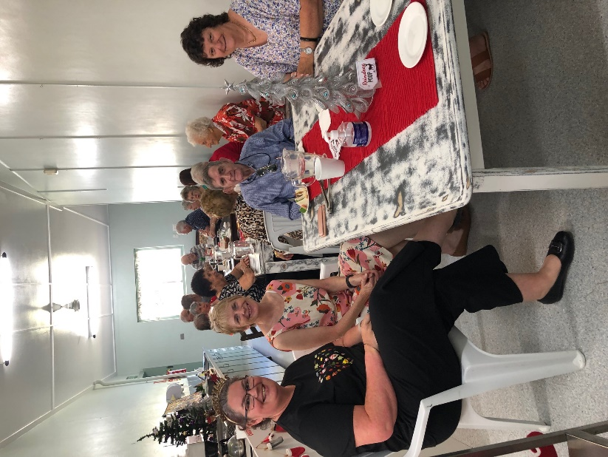
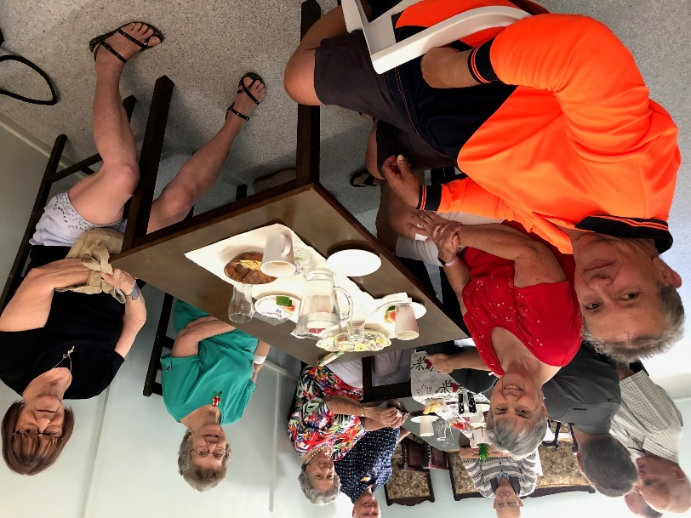
CHRISTMAS BOWLING
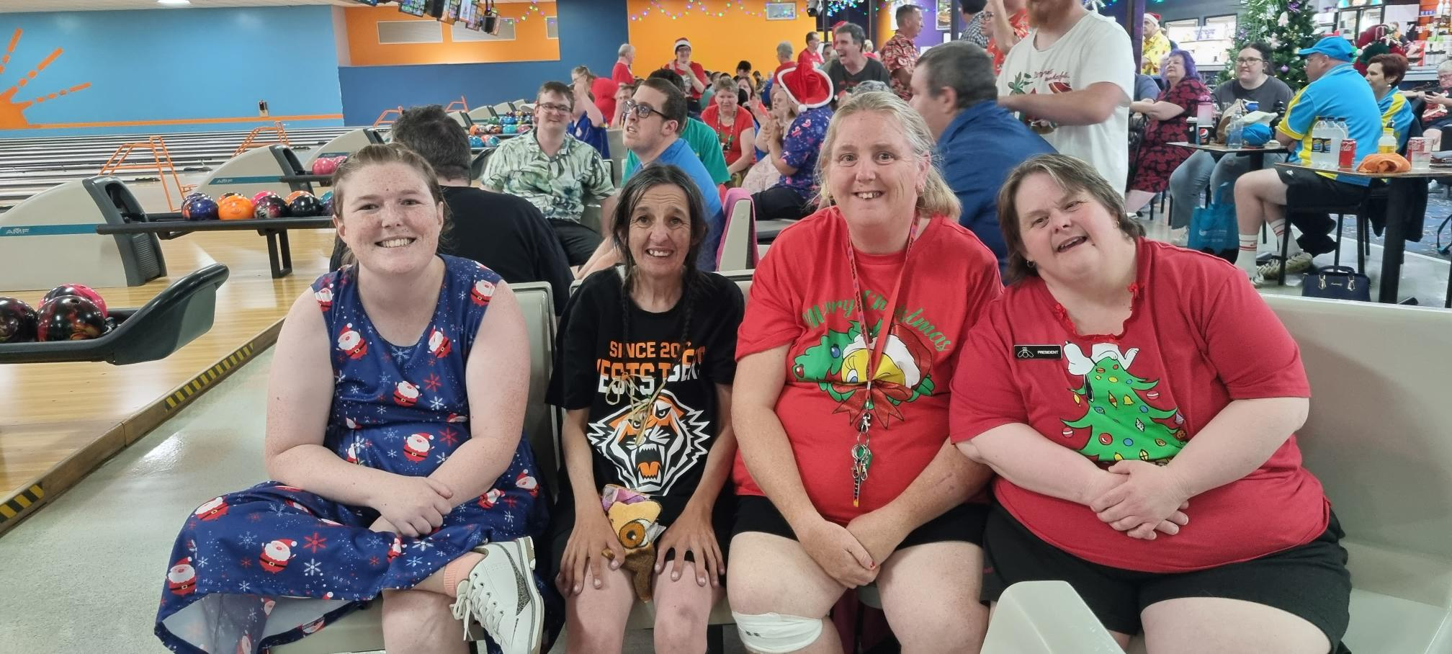

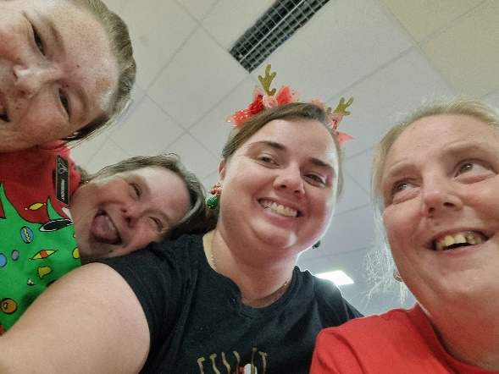
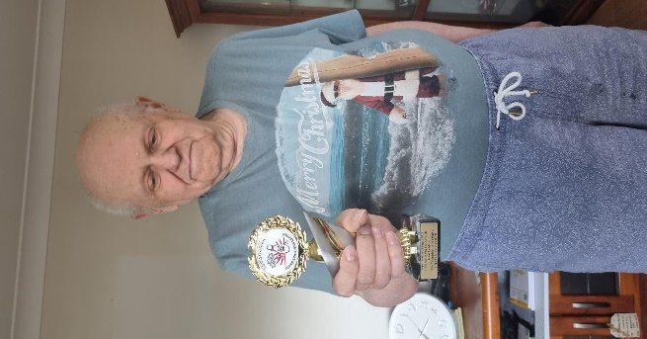
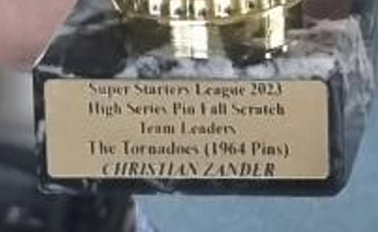
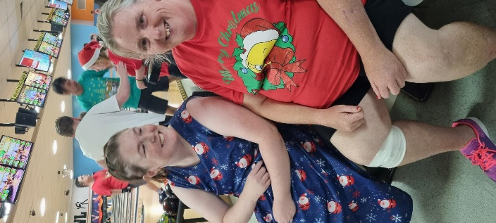
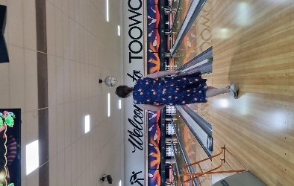
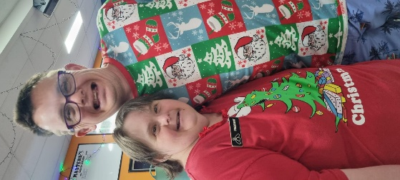
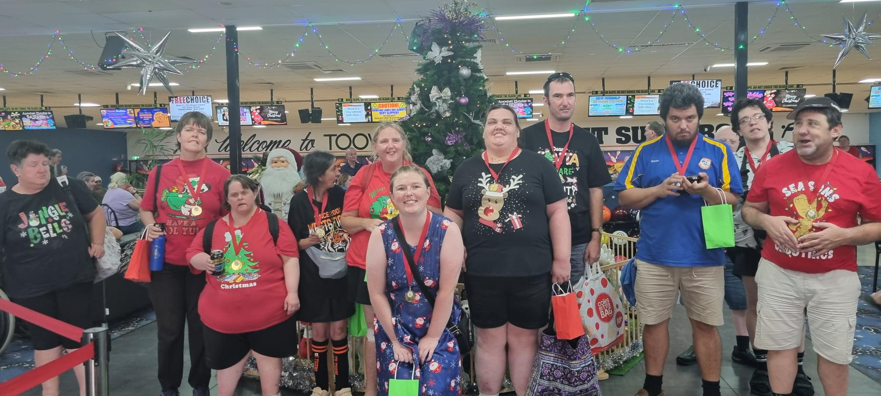
Chris Zander and his team won high series pin fall scratch team leaders!

Well done!
PERSONAL GUEST TO PARLIAMENT HOUSE

On the 21st November, Johnny Hoffman had the opportunity to have a video call with the Queensland Minister for Energy, the Honourable Mick de Brenni.

Johnny was able to demonstrate his knowledge and passion about politics. He made such a good impression on the Minister, that Mr de Brenni, invited Johnny as his personal guest to visit parliament house while it was in session, to have lunch and to have a personal tour of parliament.

Johnny visited Parliament on 28 of November, with his support worker, Sean. They also had a tour of old Government House, which is now in the grounds of the Queensland University of Technology. They both thoroughly enjoyed touring the beautifully restored old building.

They then met with Fiona, Mr de Brenni’s electorate office manager, at the Parliamentary annex. They had to go through a security check, and provide government issued identification to be allowed into the building. They had a tour of Parliament and saw, the Speaker’s Green, the Grand Staircase, and the historic foyer.

Johnny was able to sit in the visitors gallery while he observed amendments to two different pieces of legislation being debated and passed. The pieces of legislation were the Police and Emergency Services Act, and the Information Privacy Act. He saw the Police Minster debate the changes. He also saw Leanne Enoch, the Minister for Aboriginal and Torres Strait Islander affairs debate how changes to the Information Privacy Act would enable First Nations people be able to access important cultural information held in the Queensland Archives.

Johnny was fascinated by the parliamentary processes and traditions, as well as the formal decor and symbols of authority. He asked lots of questions and recognised procedures and people that he knows from his keen interest in politics. Mr de Brenni saw Johnny in the visitors gallery, and waved, and made a point of coming out to meet with Johnny and have photos taken. Johnny was able to tell the minister about the wonderful work Anuha does to support him. The Minister was very impressed with Johnny’s representation of the organisation and also with Johnny’s confidence and mature behaviour.

Johnny was shown the chamber that was formally the seat of the now defunct upper house.

Then they had lunch in the members bistro, and although he enjoyed the quality of the ”nachos”, he made assurances that it was not as good as the food he makes with his support worker, Darren.

It was a very successful and fascinating visit, and it is certain that Johnny’s charm and enthusiasm will make him most welcome for another visit in the future.

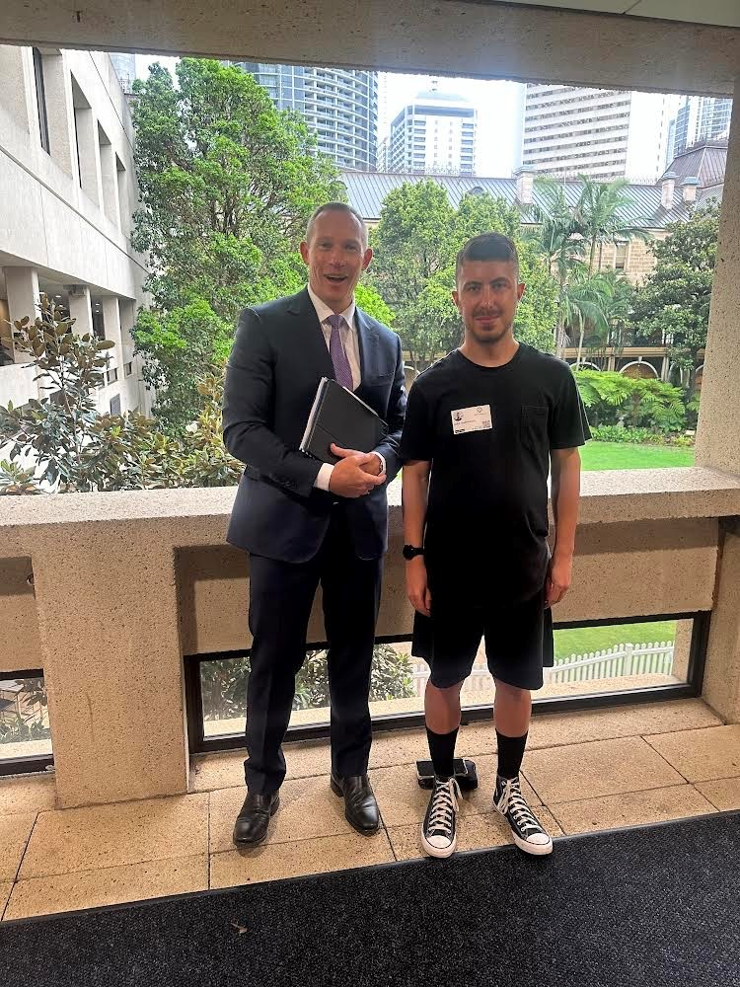
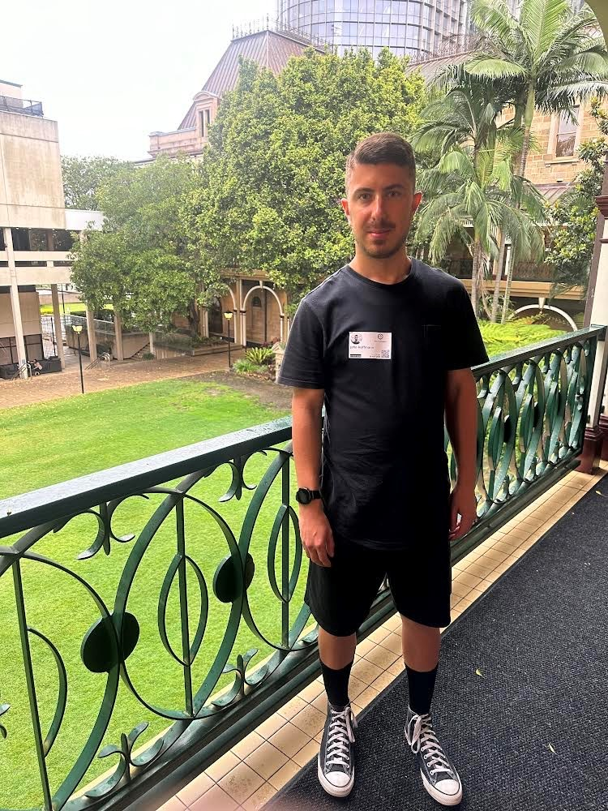
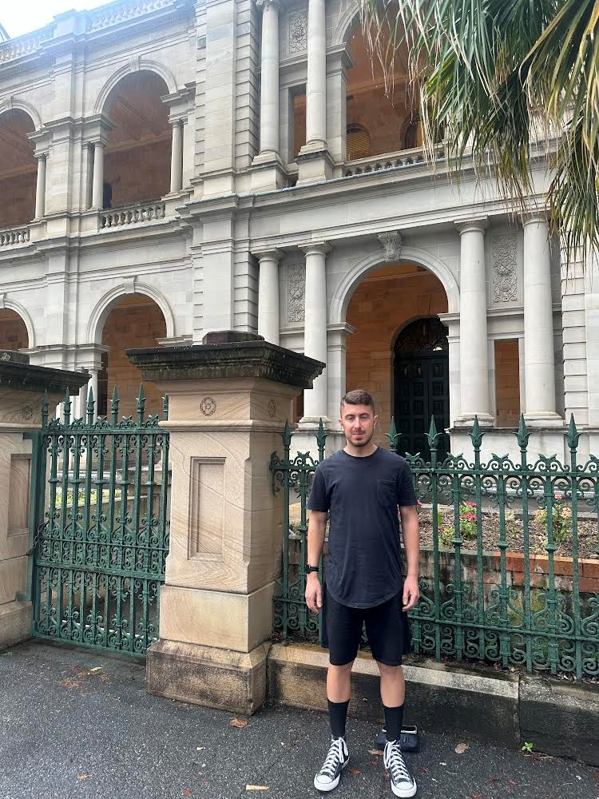
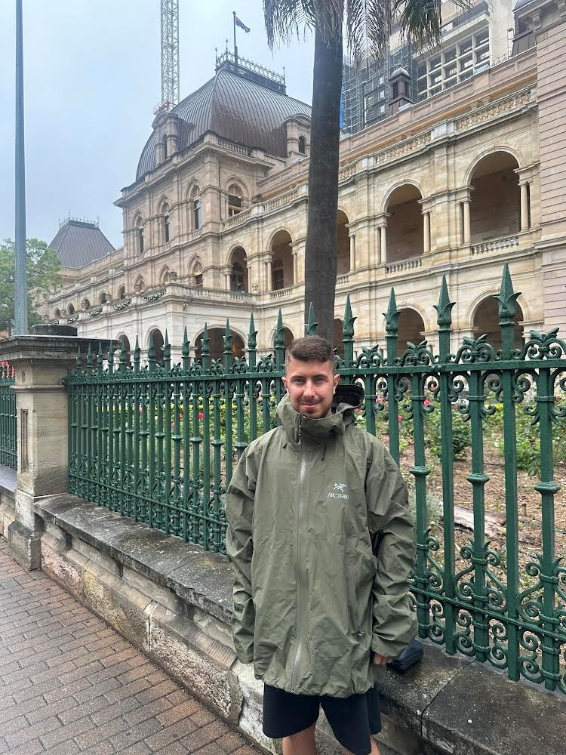
WORK EXPERIENCE

Alex joined Anuha for a week of work experience. During this time, he was able to see a variety of ways in which we provide support, including our supported employment program. He asked plenty of questions to learn what we do for our participants and how we support them in our community.

At the end of the week, Alex was presented with a Certificate of Completion.

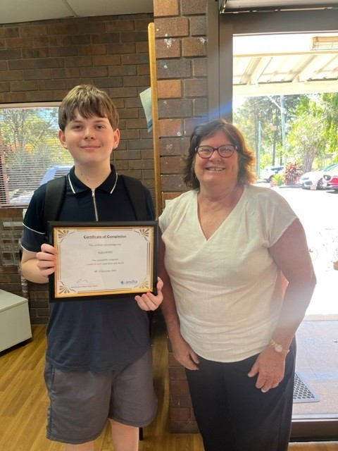

DEAN IN THE KITCHEN

Sue and Dean have been cooking some meals that are making the office smell amazing!

Each week, Sue helps Dean make some of his favourite meals – Quiche, Spaghetti, Potato Bake, Sausage and Vegetable Bakes.
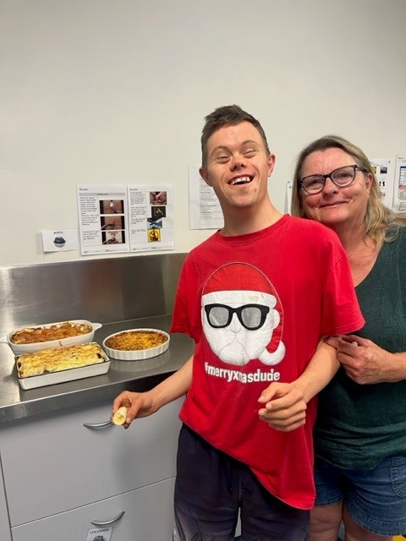
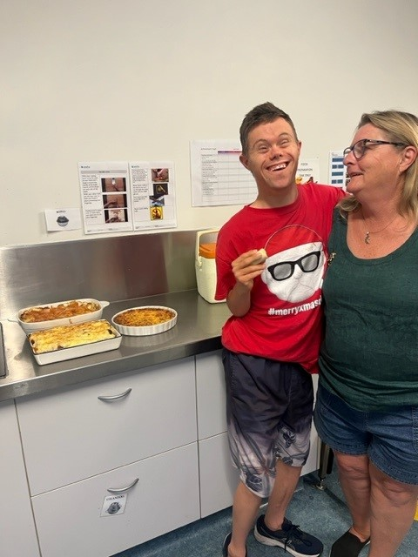
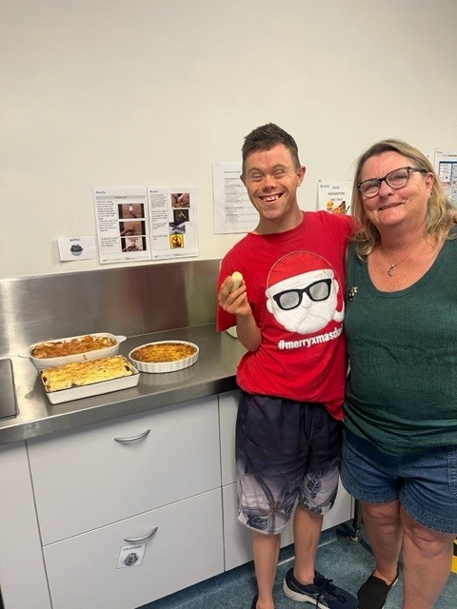
Getting into the Christmas spirit this week.
MRF NEWS

The year has flown by so quickly and here we are writing our last MRF news for 2023. Christmas is almost upon us, and summer is nearly here too. We’re already experiencing the heat but thankfully we’ve now had some rain to compensate and cool things down a bit. The group are trained in preventing heat stress. We make sure everyone is hydrated, taking breaks, has access to ice towels and if it’s far too hot we will have an ice block and call it an early day.
We’ve already started celebrating the Christmas Season. The group was invited to attend the Peace Lutheran Primary School Christmas Concert recently. This was a great experience for the team, and it was nice to share some Christmas cheer within the Church subsidiaries. We were made to feel very welcome and were provided with a nice morning tea afterwards. The group really enjoyed the “Aussie Jingle Bells” at the close of the Concert. We thank the school for their kind invitation.
We also attended the Anuha staff Christmas Party on Friday 24.11.23. We enjoyed having an afternoon off work and sharing a pizza lunch. It was nice to catch up with some of the office staff and be part of the judging of the Christmas desk decorating competition. We were amazed at some of the displays and creativity. Some of our staff were recognized for their years of service at this party and we’re very proud of their years of dedication and service to Anuha.
Criag Zampech 19 years service.
Ben Grant 17 years service.
Thomas King 10 years service.
We have had quite a few BBQ lunches over these last few months. We’ve farewelled some of the MRF team during this time. We’re sorry to see our friends go and we wish them all the best with their new ventures. We’ve also celebrated a couple of our Support workers birthday’s too. Bec and Jo coincidently have the same birthday which fell on Melbourne Cup day this year. We enjoyed a BBQ lunch, icecream cake and some office sweepstakes on this occasion.
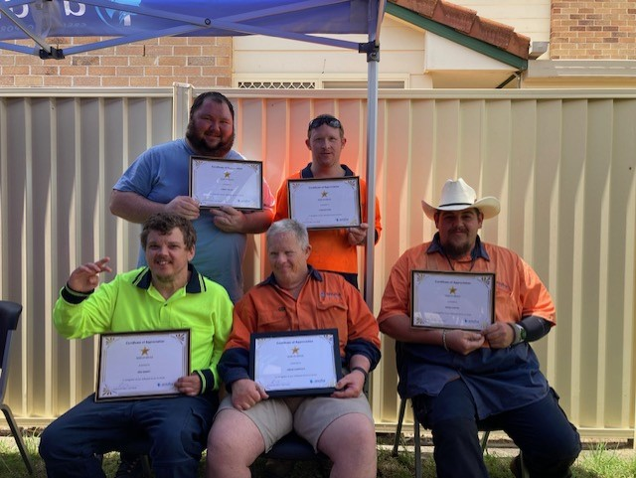
We’d like to wish everyone a very Merry Christmas and a happy new year. We’re looking forward to a bright and prosperous 2024.

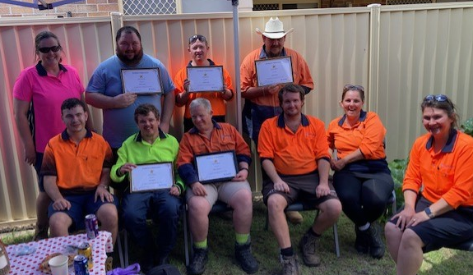
MRF Team.

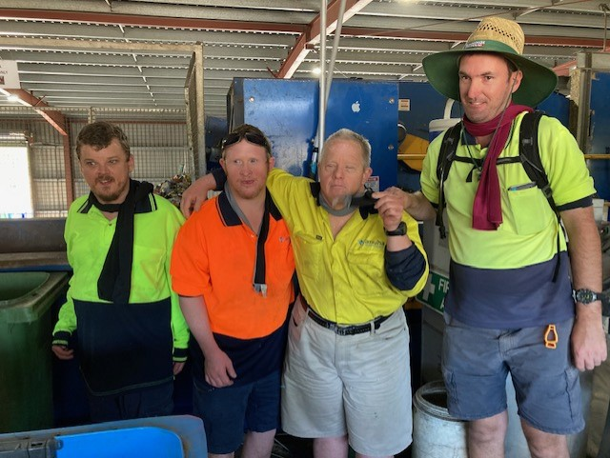
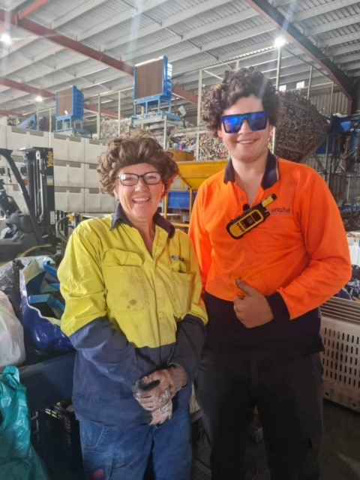
‘Mother & Son Duo’
wearing some fashionable wigs
Using ice towels to keep us cool.
Attending The Christmas Concert
COTTAGE INDUSTRIES

Kitchen News

The kitchen is a wonderful place to be in summer – nice and hot. As we approach Christmas 2023, we are ramping up kitchen activities and have been delighted to introduce some new tastes to our team. This included savoury jams like tomato jam and onion jam which were well liked by those who tasted them.

One other more divisive product Is our delightful sauerkraut which burped and bubbled away in our server room for three weeks and was met by very mixed reactions from those brave enough to taste it – despite the abundance of probiotic flora it boasted.

Jumbleberry jam is also a recent and most popular addition to our repertoire due to the fact that Woollies has stopped supplying us with mixed berries and has sent a dark fruit blend instead. This jam is full of cherries, blackberries and blackcurrants. If you have not tasted it, it is definitely worth grabbing a jar to treat your family for Christmas.

We have been back to Gatton Plaza recently and made record sales – Colin even promoted our event in the newspaper. Next week we are off to the IGA plaza to hopefully top the sales from Gatton Plaza. If you are passing please stop and say hi next Thursday morning – and, of course, grab yourself a treat.

Many of our team were delighted to attend the Country Music Festival a few weeks ago and now they are looking forward to the upcoming cruise next year. A very big thank you to every team member for your hard work and best Christmas wishes to everyone from Darelle, Tahlia, Susanne, Jamie, Corey, DJ and Judy.
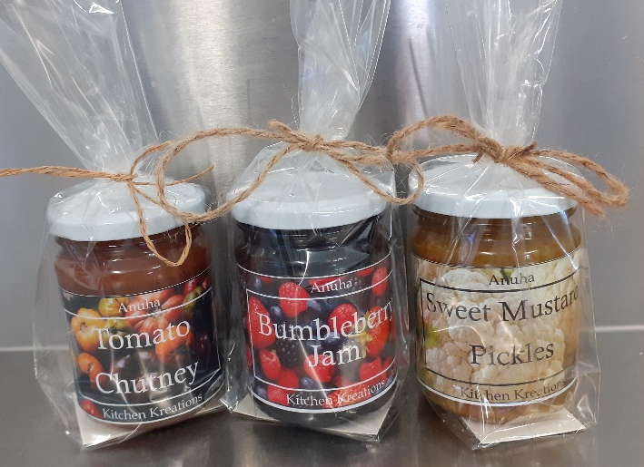
Don’t forget -Christmas Gift Ideas
Food Preparations with Darelle & Tahlia

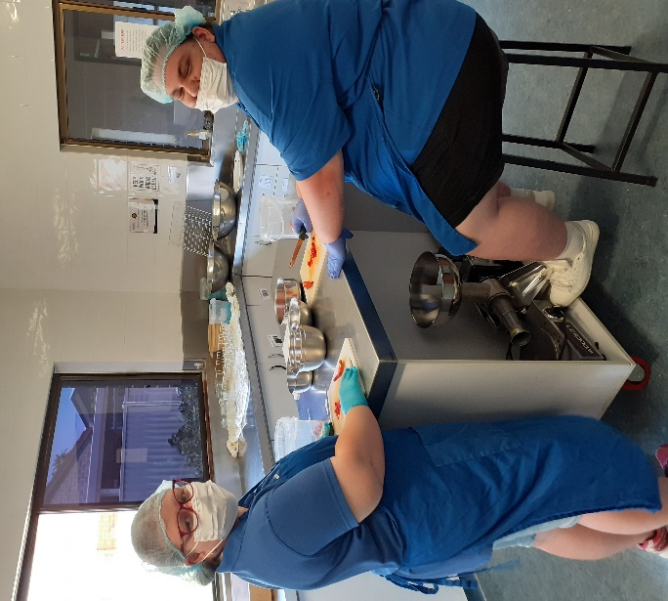
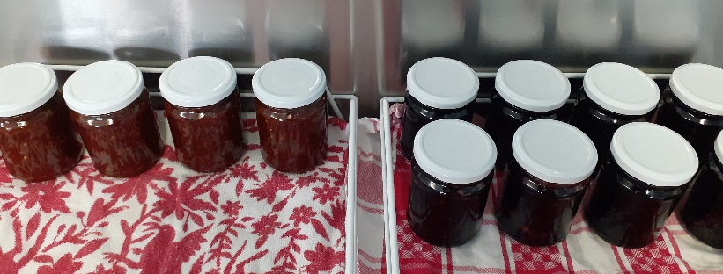
Tomato Jam & Jumbleberry Jam
TIP SHOP NEWS

Well, it’s been a big year here at the Tip Shop with lots of improvements and heaps of great donations.
We say goodbye and well done to Johnny, who is off to his new job. He has been a great team member and will be missed.
Ernie is going great guns, he has flourished working in the Tip Shop with great enthusiasm.
Craig has been working the till and eftpos machine and getting better all the time.
Thomas is working well and is here every other Friday helping out.
Stan is working every Saturday and has been very helpful.
Josh is fixing up all the timber bits and pieces
Tracey is doing great work and has become our clothing expert, sorting, hanging and bagging up clothes for sale.
Keep up the great work team.
Merry Christmas and a Happy New Year, we will see you all next year.
Thanks for your support.
Mark
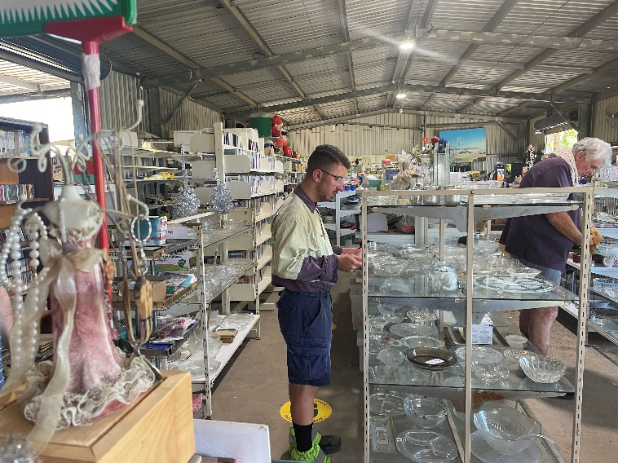
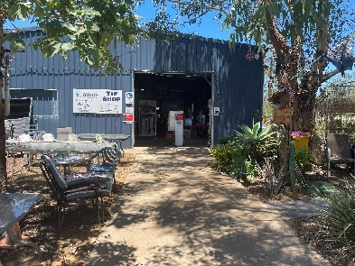
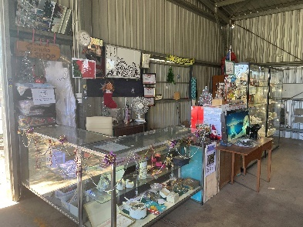

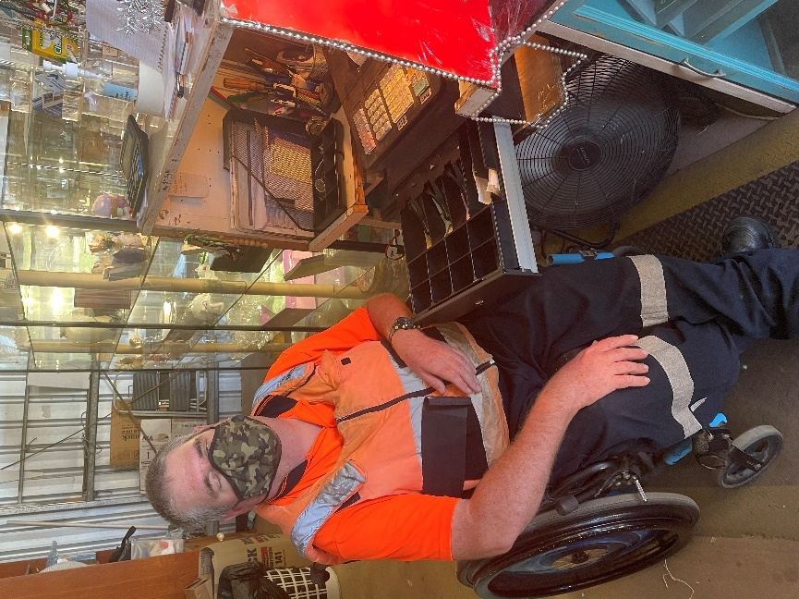
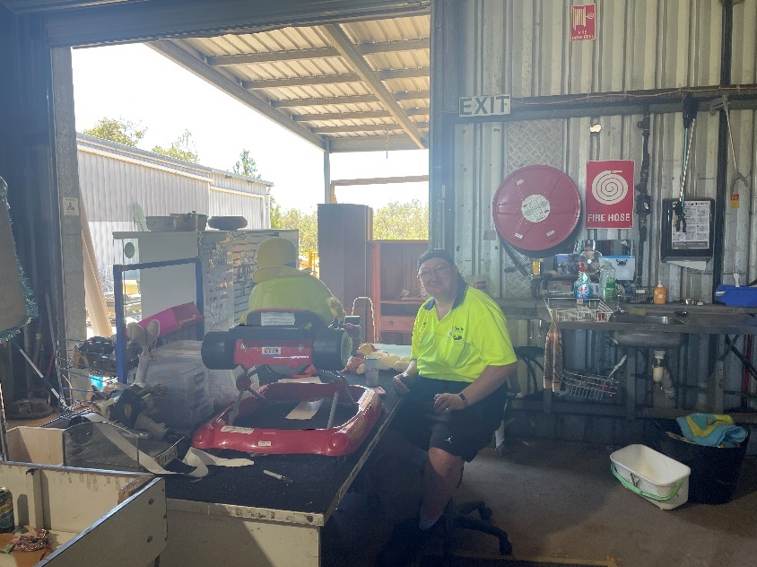

FROM THE CHAPLAIN

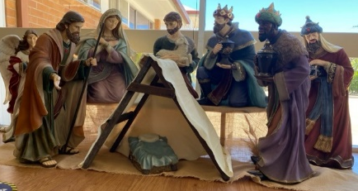
Newsletter Devotion December 2023
Matthew 1:18-23
¹⁸ This is how the birth of Jesus the Messiah came about: His mother Mary was pledged to be married to Joseph, but before they came together, she was found to be pregnant through the Holy Spirit. ¹⁹ Because Joseph her husband was faithful to the law, and yet did not want to expose her to public disgrace, he had in mind to divorce her quietly.
²⁰ But after he had considered this, an angel of the Lord appeared to him in a dream and said, “Joseph son of David, do not be afraid to take Mary home as your wife, because what is conceived in her is from the Holy Spirit. ²¹ She will give birth to a son, and you are to give him the name Jesus, because he will save his people from their sins.”
²² All this took place to fulfill what the Lord had said through the prophet: ²³ “The virgin will conceive and give birth to a son, and they will call him Immanuel” (which means “God with us”).

As I write this, we are about to enter the season of Advent, a time of preparation for celebrating again the coming of Jesus. It prepares for that special time of year: Christmas! It is a time of parties, gifts, and joy and peace and hope. Families come together around shared meals, and special effort is made to catch up with those we haven’t seen for a while. It is a wonderful time!

BUT incongruously, we are also seeing on the nightly news the desperation of people in Gaza with so much grief, mourning, loss, and destruction. And don’t forget the people in Ukraine who are still defending themselves from the attacks of Putin’s army, or the countless other places around the world, like Sudan or Myanmar, or any of the other places that don’t appear in our news. What difference does Christmas make?

This baby whose birth we celebrate again at Christmas is himself no stranger to suffering and injustice and persecution. Jesus was not born in a privileged palace, nor even a guest room, but came into the world in humble circumstances and was placed in a manger, an animal’s feeding trough (Luke 2:6-7). Like many people in our world today, Jesus and his family fled persecution from Herod and became refugees In Egypt (Matthew 2:13-14). Jesus grew up and suffered injustice at the hands of Pilate and the Jewish leaders of the time, ultimately being killed by them. In his life, Jesus associated with and ate with those who were despised, downtrodden and ignored.

So what difference does Christmas make? Christmas reminds us that God chooses to join us in our muck, our struggles, our pain, our suffering. Jesus reminds us that God is with us, whatever we are going through. In fact, this is highlighted in the Gospel of Matthew where it gives Jesus the name “Immanuel”, which means “God with us”. And at the end of that Gospel, Jesus promises, “And surely I am with you always, to the very end of the age.” (Matthew 28:20)

As we celebrate and enjoy all the Christmas traditions and festivities, let us also offer prayers for mercy, justice, healing, and reconciliation for all places where suffering dwells. And let us also remind each other that God is with us even in our suffering and struggles.

Peace and joy to you always!
Pastor Noel
COMING UP…
Anuha Monthly Movie Outing
1st Tuesday of the month

All movie outings will be conducted according to COVID-19 guidelines and may be subject to change. Anuha will notify you if this applies to any movie outing or if times change.
I understand that support will be charged to my NDIS Plan at a Group Ratio dependant on numbers attending (1:1 support can be organised if required). Transport costs will be shared amongst participants attending each outing.
Please fill out the form below to express interest in attending.
Cinema: Riverlink Ipswich on Tuesdays 9am-2pm.
(Outing times are subject to movie suitability.)
Ticket cost will be $10 plus spending for lunch.

Name: ………………………………………………….

Signature: ………………………………………….
Date: / /

Anuha Craft Group
Fortnightly Tuesday’s

Venue: Peace Lutheran Church Meeting room 9:30am-1pm
Date and Time | Theme | Cost | Yes | No | Money Due By
16th and 30th January | Summertime blues | $15 |  |  | 09/01/24
13th and 27th  February | Swinging Time | $15 |  |  | 30/01/24
12th and 26th March | New beginnings | $15 |  |  | 27/02/24
9th and 23rd April | Vintage and retro | $15 |  |  | 27/03/24
7th and 21st May | Paper creations | $15 |  |  | 23/04/24
4th and 18th June | Wintertime fun | $15 |  |  | 21/05/24
All activities will be conducted according to current Covid-19 guidelines. All craft activities require you to wear old clothes and closed in shoes. All money will need to be paid no later than the dates provided. This form must be filled out and returned to the office with full payment on or before the money due by date. This is for rostering and organization of craft materials.  Name: ……………………………………….  Sign: ………………………………………………… |  |  |  | Date:  / /2024
Feel free to bring morning tea and please note there is a coffee shop on site if you would like to make a purchase.
OUT AND ABOUT
Anuha Group Outings - Fortnightly on Fridays

All activities will be conducted according to COVID-19 guidelines and may be subject to change. Anuha will notify you if this applies to an outing of your choice. For outdoor activities, a final decision based on forecasted weather conditions will be made on the Wednesday before the outing. Departure and return times for each activity will be confirmed closer to the date.

Please wear sun smart clothing and bring a water bottle, hat and sunglasses on every outing. Covered shoes suitable for walking are recommended.

By signing below, I agree to participate in the activities which I have selected. I understand that support will be charged to my NDIS Plan at a Group Ratio dependant on numbers attending (1:1 support can be organised if required). Transport costs will be shared amongst participants attending each outing.

Please select all outings you would like to attend and return your completed flyer to the Anuha office by Friday December 22nd, 2023.
Participants wishing to attend theatre performances will need to ensure their pre-payment has been made by the date stated on this flyer so that bookings can be finalised.

Name: …………………………………………………. Signature: ………………………………. Date: / /2023

DATE | EVENT | APPROX COST | OTHER EXPENSES | YES | NO
19/01/2024 | Milne Bay Aquatic & Fitness Centre  Depart 9 am, return 3 pm | $8 Entry  $25 to purchase lunch | Transport approx. 80 km
Saturday  03/02/2024 | Valentines’ day dance party  (Fancy dress optional)  Provided by wagtail services.  Depart 5pm, Return 10pm Approx | $15 (Covers 1 sausage on bread and a drink.)  Extra sausage $1 extra drink $2 | Transport  90km
16/02/2024 | Workshop Rail Museum  Depart 9:00 am, return 3:00 pm | $15 Entry  $25 for lunch | Transport approx. 110 km
01/03/2024 | Southbank Parklands, including City Cat trip from Guyatt Park-Macquarie Street, St Lucia to South Bank Parklands | Go Card $5  Lunch $25 | Transport approx.  180
15/03/2024 | Cobb and co museum Toowoomba return to Gatton lunch at colonial cafe and see Truck Museum | $10 entry  $30 lunch | Transport approx. 130 km
Wednesday  27/03/2024 | Beauty and the beast the Musical  QPAC 1 pm performance  Depart Anuha 9 am, return by 5 pm  $75 (concession) Pre-payment required by 16/01/2023 | Tickets $75 (concession), $40 to purchase lunch and snack | Transport approx. 150 km
12/04/2024 | Shark and Ray Gardens, Loganholme  Depart 9 am, return 4 pm | $35 entry, $25 to purchase lunch | Transport approx. 180 km
26/04/2024 | Summer Land Camels  Depart 9 am, return 2 pm | $30, $25 to purchase lunch | Transport approx. 145 km
10/05/2024 | Queen’s Park Zoo and Japanese Gardens, Ipswich | $10 for shared BBQ lunch | Transport approx. 120 km.
24/05/2024 | Mini golf and driving range.  City Golf Club Toowoomba  Depart 9 am, return 3 pm | $15 per game, $25 lunch | Transport approx. 75 km
07/06/2024 | Toowoomba Japanese Gardens  Depart 9 am, return 2 pm | $25 to purchase lunch | Transport approx. 80 km
21/06/2024 | ArtVo Gold Coast  Robina Town Centre  Depart 9 am, return 4 pm | $30 entry, $25 for lunch | Transport Approx. 290 km

If you would like to contribute a photo,
story or other item to the Anuha Buzz
please email office@anuha.com.au

